**Graph Data Structure**

Graph is a data structure that consists of following two components:  
**1.** A finite set of vertices also called as nodes.  
**2.** A finite set of ordered pair of the form (u, v) called as edge. The pair is ordered because (u, v) is not same as (v, u) in case of a directed graph(di-graph). The pair of the form (u, v) indicates that there is an edge from vertex u to vertex v. The edges may contain weight/value/cost.

Graphs are used to represent many real-life applications: Graphs are used to represent networks. The networks may include paths in a city or telephone network or circuit network. Graphs are also used in social networks like linkedIn, Facebook. For example, in Facebook, each person is represented with a vertex(or node). Each node is a structure and contains information like person id, name, gender and locale. See [this](http://en.wikipedia.org/wiki/Graph_theory#Applications)for more applications of graph.

Following is an example of an undirected graph with 5 vertices.  
https://cdncontribute.geeksforgeeks.org/wp-content/uploads/undirectedgraph.png

Following two are the most commonly used representations of a graph.  
**1.** Adjacency Matrix  
**2.** Adjacency List  
There are other representations also like, Incidence Matrix and Incidence List. The choice of the graph representation is situation specific. It totally depends on the type of operations to be performed and ease of use.

**Adjacency Matrix:**  
Adjacency Matrix is a 2D array of size V x V where V is the number of vertices in a graph. Let the 2D array be adj[][], a slot adj[i][j] = 1 indicates that there is an edge from vertex i to vertex j. Adjacency matrix for undirected graph is always symmetric. Adjacency Matrix is also used to represent weighted graphs. If adj[i][j] = w, then there is an edge from vertex i to vertex j with weight w.

The adjacency matrix for the above example graph is:  
Adjacency Matrix Representation

*Pros:* Representation is easier to implement and follow. Removing an edge takes O(1) time. Queries like whether there is an edge from vertex ‘u’ to vertex ‘v’ are efficient and can be done O(1).

*Cons:* Consumes more space O(V^2). Even if the graph is sparse(contains less number of edges), it consumes the same space. Adding a vertex is O(V^2) time.

**Adjacency List:**  
An array of linked lists is used. Size of the array is equal to the number of vertices. Let the array be array[]. An entry array[i] represents the linked list of vertices adjacent to the***i***th vertex. This representation can also be used to represent a weighted graph. The weights of edges can be stored in nodes of linked lists. Following is adjacency list representation of the above graph.

Adjacency List Representation of Graph

**Breadth First Search:**

Breadth First Search (BFS) algorithm traverses a graph in a breadthward motion and uses a queue to remember to get the next vertex to start a search, when a dead end occurs in any iteration.

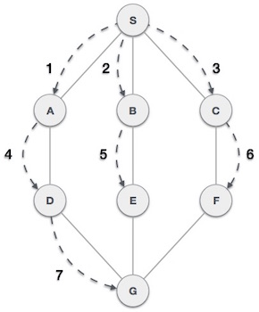

As in the example given above, BFS algorithm traverses from A to B to E to F first then to C and G lastly to D. It employs the following rules.

* **Rule 1** − Visit the adjacent unvisited vertex. Mark it as visited. Display it. Insert it in a queue.
* **Rule 2** − If no adjacent vertex is found, remove the first vertex from the queue.
* **Rule 3** − Repeat Rule 1 and Rule 2 until the queue is empty.

|  |  |  |
| --- | --- | --- |
| **Step** | **Traversal** | **Description** |
| 1 | Breadth First Search Step One | Initialize the queue. |
| 2 | Breadth First Search Step Two | We start from visiting **S**(starting node), and mark it as visited. |
| 3 | Breadth First Search Step Three | We then see an unvisited adjacent node from **S**. In this example, we have three nodes but alphabetically we choose **A**, mark it as visited and enqueue it. |
| 4 | Breadth First Search Step Four | Next, the unvisited adjacent node from **S** is **B**. We mark it as visited and enqueue it. |
| 5 | Breadth First Search Step Five | Next, the unvisited adjacent node from **S** is **C**. We mark it as visited and enqueue it. |
| 6 | Breadth First Search Step Six | Now, **S** is left with no unvisited adjacent nodes. So, we dequeue and find **A**. |
| 7 | Breadth First Search Step Seven | From **A** we have **D** as unvisited adjacent node. We mark it as visited and enqueue it. |

At this stage, we are left with no unmarked (unvisited) nodes. But as per the algorithm we keep on dequeuing in order to get all unvisited nodes. When the queue gets emptied, the program is over.

Code For BFS: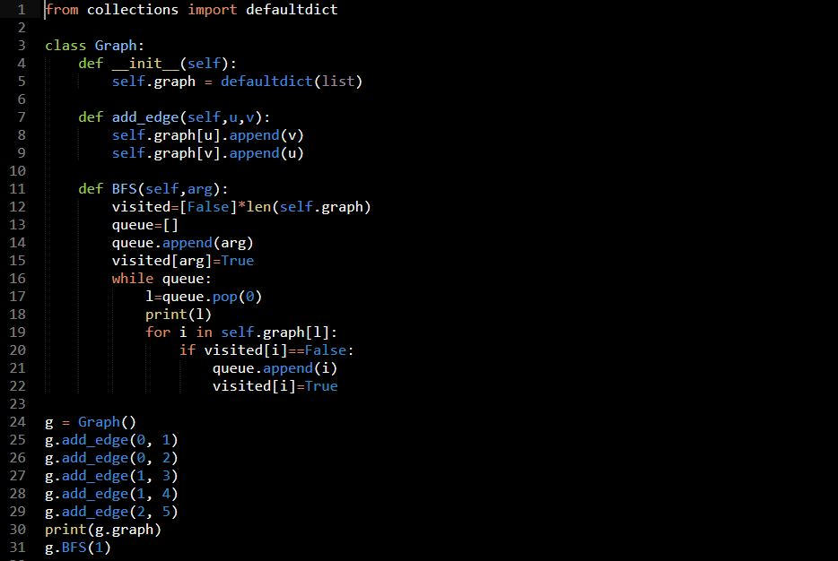

Reference Link For BFS: <https://github.com/Satyam-Bhalla/Acadview-Python/blob/master/Data%20Structures/bfs.py>

**Depth First Search:**

Depth First Search (DFS) algorithm traverses a graph in a depthward motion and uses a stack to remember to get the next vertex to start a search, when a dead end occurs in any iteration.

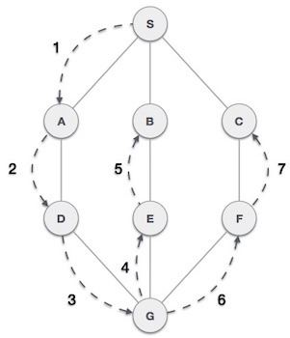

As in the example given above, DFS algorithm traverses from S to A to D to G to E to B first, then to F and lastly to C. It employs the following rules.

* **Rule 1** − Visit the adjacent unvisited vertex. Mark it as visited. Display it. Push it in a stack.
* **Rule 2** − If no adjacent vertex is found, pop up a vertex from the stack. (It will pop up all the vertices from the stack, which do not have adjacent vertices.)
* **Rule 3** − Repeat Rule 1 and Rule 2 until the stack is empty.

|  |  |  |
| --- | --- | --- |
| **Step** | **Traversal** | **Description** |
| 1 | Depth First Search Step One | Initialize the stack. |
| 2 | Depth First Search Step Two | Mark **S** as visited and put it onto the stack. Explore any unvisited adjacent node from **S**. We have three nodes and we can pick any of them. For this example, we shall take the node in an alphabetical order. |
| 3 | Depth First Search Step Three | Mark **A** as visited and put it onto the stack. Explore any unvisited adjacent node from A. Both **S**and **D** are adjacent to **A** but we are concerned for unvisited nodes only. |
| 4 | Depth First Search Step Four | Visit **D** and mark it as visited and put onto the stack. Here, we have **B** and **C** nodes, which are adjacent to **D** and both are unvisited. However, we shall again choose in an alphabetical order. |
| 5 | Depth First Search Step Five | We choose **B**, mark it as visited and put onto the stack. Here **B**does not have any unvisited adjacent node. So, we pop **B**from the stack. |
| 6 | Depth First Search Step Six | We check the stack top for return to the previous node and check if it has any unvisited nodes. Here, we find **D** to be on the top of the stack. |
| 7 | Depth First Search Step Seven | Only unvisited adjacent node is from **D** is **C** now. So we visit **C**, mark it as visited and put it onto the stack. |

As **C** does not have any unvisited adjacent node so we keep popping the stack until we find a node that has an unvisited adjacent node. In this case, there's none and we keep popping until the stack is empty.

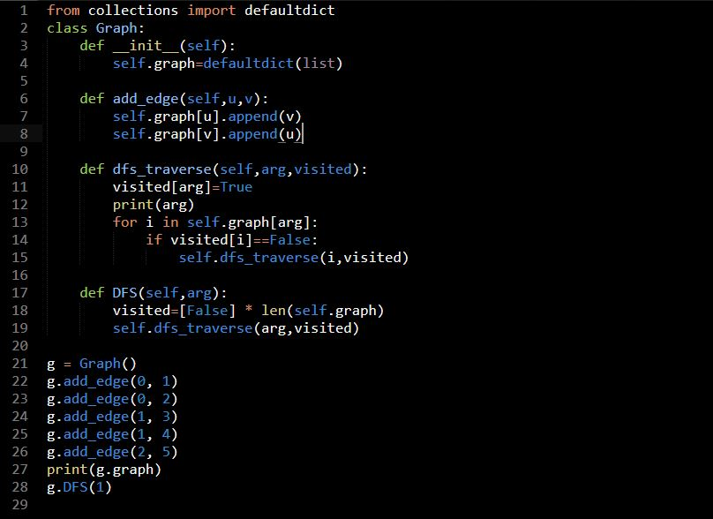

Reference Link For DFS: <https://github.com/Satyam-Bhalla/Acadview-Python/blob/master/Data%20Structures/dfs.py>

**Connected Island Problem:**

Reference Link: <https://www.youtube.com/watch?v=R4Nh-EgWjyQ&t=6s>

Python Code For Connected Islands Problem

